Networking Protocols

DHCP

- Create a LAN with 3 PCs and a server.
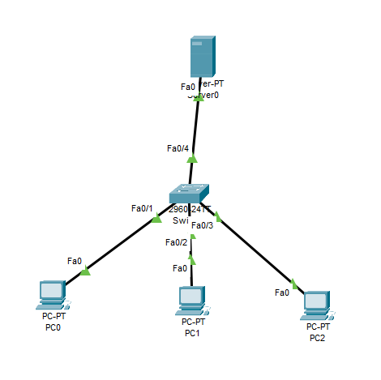
- Configure the server’s Fastethernet0
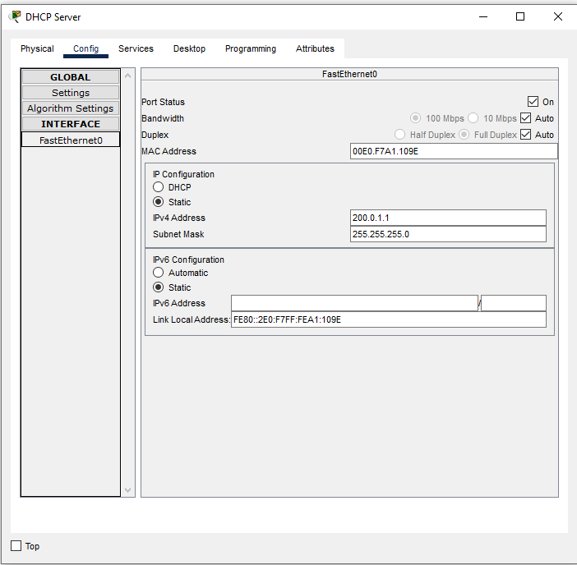
- Under Services, select DHCP.
- Set up the DHCP Service
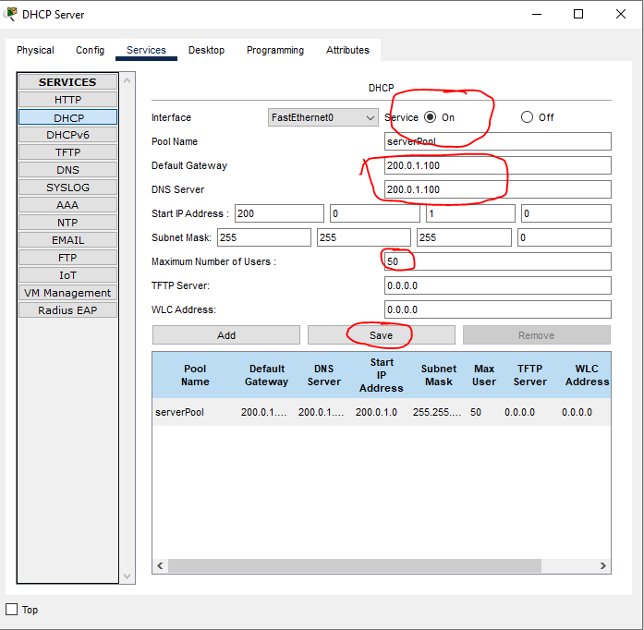
- Setup all the PCs.
  - Set Fastethernet0 to DHCP
- What is the IP Information of the 3 computers (go to Config and look at settings and Fast ethernet0):
PC | IP address | Subnet Mask | Default Gateway | DNS Server
PC0 | 200.0.1.2 | 255.255.255.0 | 200.0.1.100 | 200.0.1.100
PC1 | 200.0.1.3 | 255.255.255.0 | 200.0.1.100 | 200.0.1.100
PC2 | 200.0.1.4 | 255.255.255.0 | 200.0.1.100 | 200.0.1.100
- In this example, what did DHCP do?
DHCP went in and set all the Ip’s, gateways, and DNS server for all the pc’s, it understands what the network is and from there sets everything else up.
- If you have a Microsoft domain, the easiest way to have a DHCP server in your network is to activate the DHCP service on your window’s IIS server. What other free DHCP alternatives are available for a home network (name at least 2)? 2 other free DHCP alternatives are Kea DHCP which is very modern and supports IPv4 and IPv6. Dnsmasq is another one and it is very good for small networks. It also uses very little resources from your system.

DNS
- Create a LAN with 2 PCs and 2 servers.
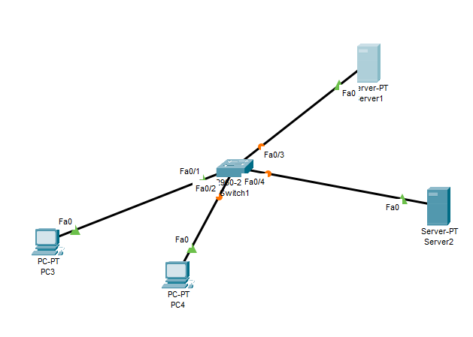
- Setup the IP addresses of the devices as shown in table 1:
Device | IP address | DNS Server
Server1 | 200.1.1.1 | 200.1.1.2
Server2 | 200.1.1.2 | 200.1.1.2
PC0 | 200.1.1.101 | 200.1.1.2
PC1 | 200.1.1.102 | 200.1.1.2

- Click on server1. Click on the Services tab. Notice that both the HTTP and HTTPS services are on. Edit the index.html. Instead of saying “Welcome to Cisco Packet Tracer. Opening doors to new opportunities. Mind Wide Open.” Change it to “Welcome to Jack’s server” (Replace Jack with your first name!)
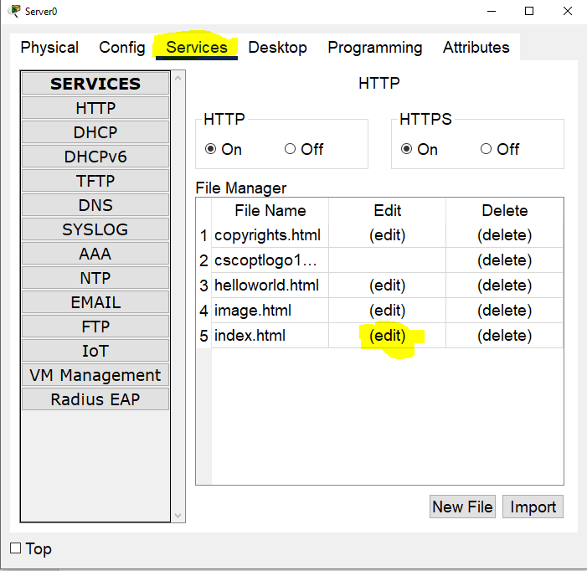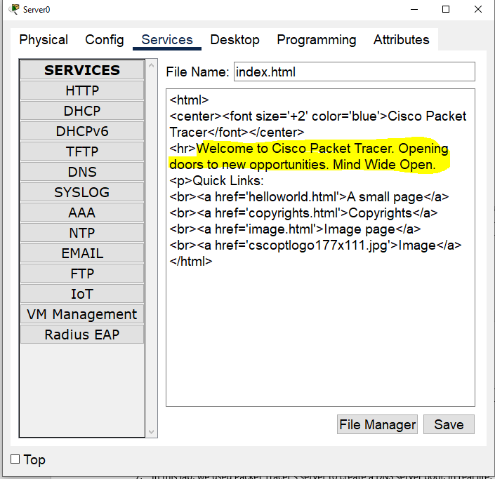
- Setup Server2 to be a DNS server with the following entries (Replace Jack with your first name):
Jackpc.com | 200.1.1.102
Jackweb.com | 200.1.1.1
- In PC1:
  - Ping jackpc.com (take a screenshot)
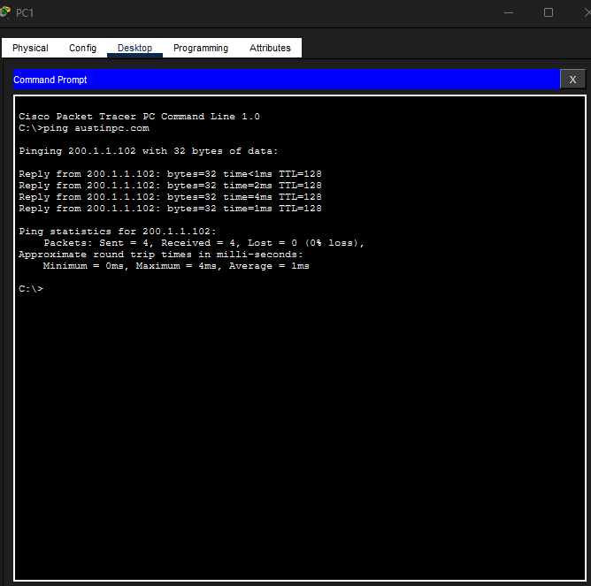
  - Ping jackweb.com (take a screenshot)
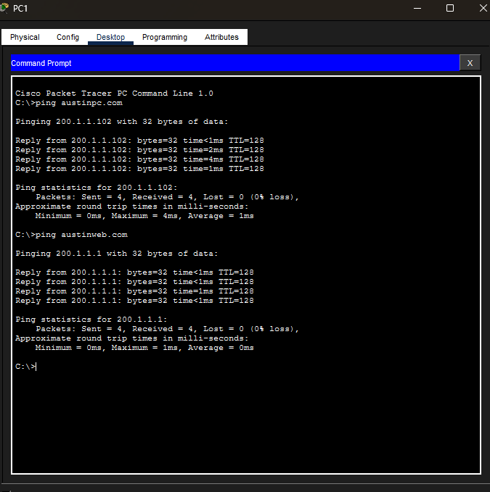
  - Open the web browser, and browse to jackweb.com (Take a screenshot)
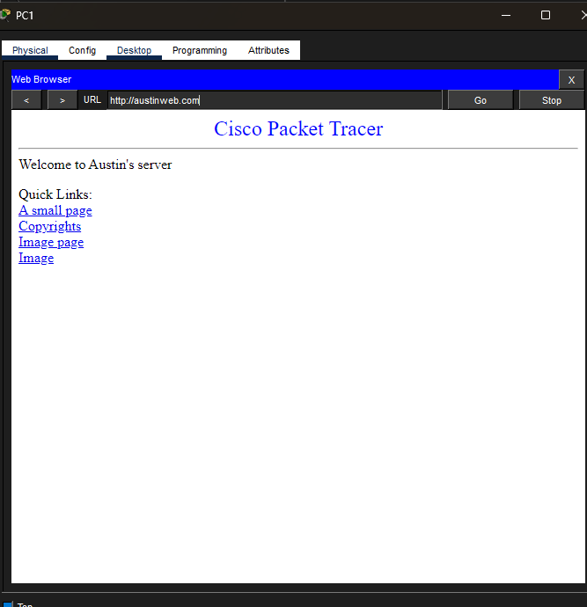
- What did DNS do in this lab?
DNS allowed us to use IP’s so the other devices were able to communicate, this is the reason we could ping the webserver.
- In this lab, we used Packet Tracer’s server to create a DNS server pool. In real life, if you wanted to have a DNS server on your internal network, what are your options? Name 3 DNS Servers that you can download for free
3 other DNS servers that you can use for free are BIND, Microsoft DNS, and dnsmasq.

